Job & Family Services Application Instructions
All documents mentioned can be found L drive SAMHSAStaff FolderJFS Paperwork
Questions to ask before starting:
- Have you received benefits in Franklin County before?
No
We will need to provide your ID, BC, and SS card in order to get you approved
Yes
We do not need to provide proof of ID, BC, or SSN

The last time you received benefits was anyone else on the case with you (children, family members, significant other, etc.)?

Yes
And you DON’T want them to be on the case again, you may be asked to provide addtl docs if there are significant changes in your income or if you’ll be using the same address for your residence as you did on the case with this person/these people.

Yes
And you want them to be on the case with you again, you will need to know their full SSN & DOB

No
Then proceed with just your information!

- Would you like to declare you live at an address OR if your living situation is unstable, would you like to declare you have a mailing address where JFS can send paperwork?
Mailing Address Verification
The person who’s name is on the lease or mortgage of that residence will need to complete the Mailing Address verification for you.

Address Verification
The person whose name is on the lease or mortgage will need to complete the Address Verification letter for you. OR provide a copy of the lease or mortgage with your name on it.

Address Verification Template

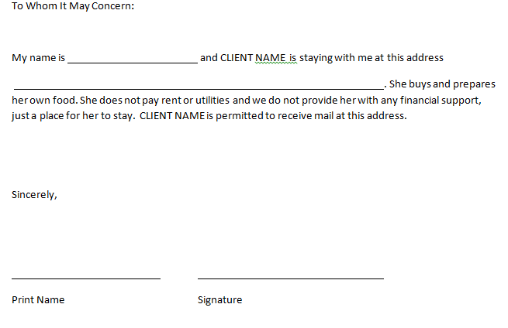
Mailing Address Verification Template

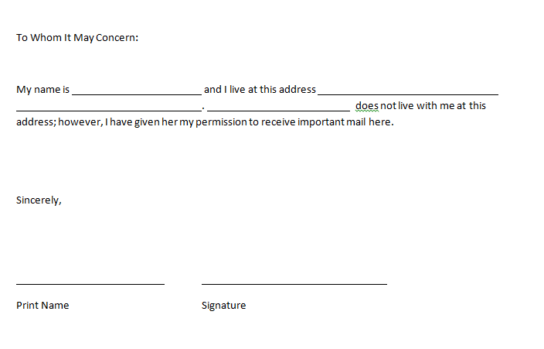
Eligibility Information
Income
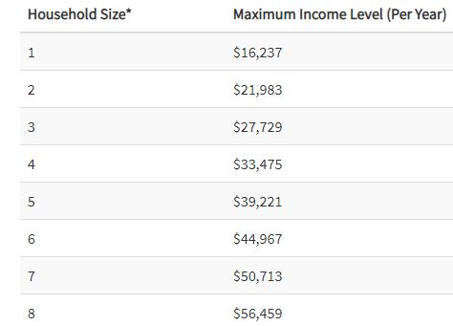
Able-Bodied Adults Without Dependents (ABAWDS)
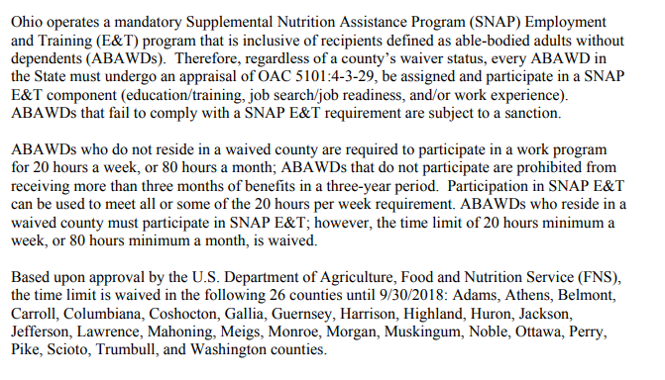

Filling Out the Application
Page 1: You do not need this page
Page 2: Generally ignore this page unless they have NEVER received benefits before OR if they declare a certain type of income and need to know what documentation needs provided to prove it.
Page 3: This is where the application begins
Part 1: Voter Registration
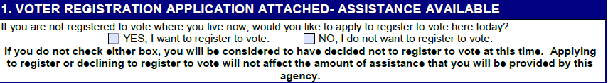
This section is not required to be completed to submit the application. If they check “Yes”, have them complete page 7.

Part 2: Tell us which program(s) you are applying for
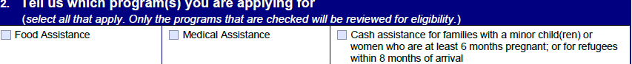
Check ALL forms of assistance the individual is applying for. If they are unsure if they’re medical is active, have them check the medical box and JFS will at the very least confirm it is active.
Part 3: Tell us about you (the applicant)
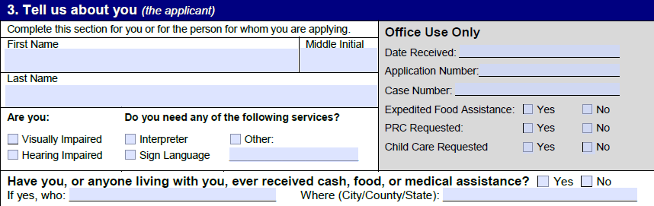
Please remember to have them fill out the bottom question about when or not they have received county assistance before.
Part 4: Tell us how to reach you
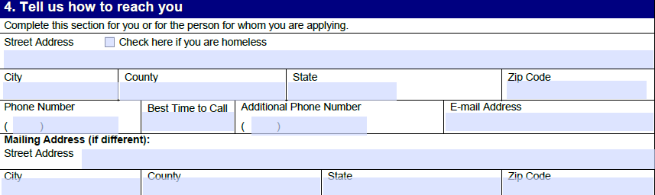

This section is completed based on their answer to question #2 of “Questions to ask before you start.”
- If declaring they live at an address, the first address section needs completed
- If declaring a Mailing Address, check the “Check here if you are homeless” box and then fill in the Mailing Address section

For phone numbers, this is the number that will be attached to their case. If they do not have a phone number, that’s ok, they will just receive ALL communication from JFS via mail and have to completed in-person appointments if they are ABAWD eligible.
**If they provide a phone number, that is the number that will be called for an ABAWD eligibility interview so it must be active when that happens.
We DO NOT have the ladies put the OJPP office address as their Mailing Address. We have tried this numerous times and the food assistance information has never made it to our office. We have explored all possible reasons why and cannot find an answer. So to prevent them from wasting time, we have them select a different mailing address.

Part 5: Tell us if you are an Authorized Representative
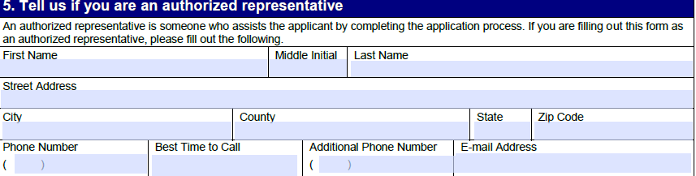
This section only needs filled out if someone has been given Power of Attorney or is legally deemed an authorized representative for the person applying. Proof of either status will be required if completed.
Part 6: Sign Here
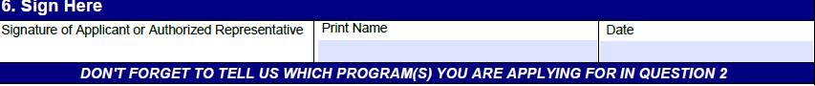
The applicant must sign, print their name, and date

Part 7: Tell us if you need food assistance right away
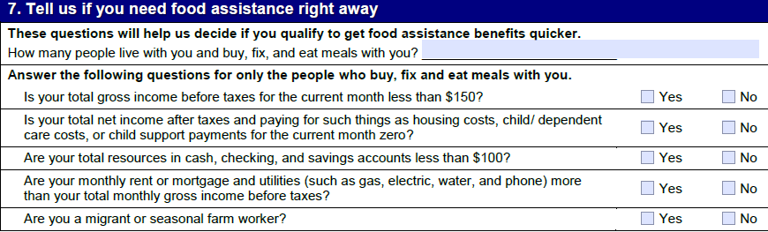
The first question is tricky. For single individuals on the case the answer will always be 0. For individuals listing a family, it is the number of people minus themselves.
The second series of questions it is important for them to read carefully and fill out accurately, often times ladies will speed through this and select an incorrect answer.

Part 8: Tell us about the people in your home
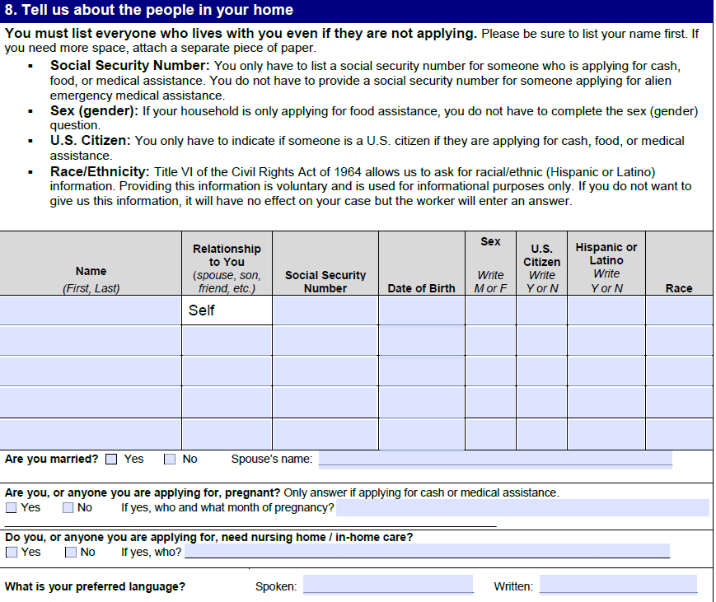
For clients who are the only person on their case, JFS advised us to only list their information here. If they have individuals they want on their case, they will need to complete ALL columns for each individual before the application is considered complete.
Part 9: Tell us about the people in your home (continued)
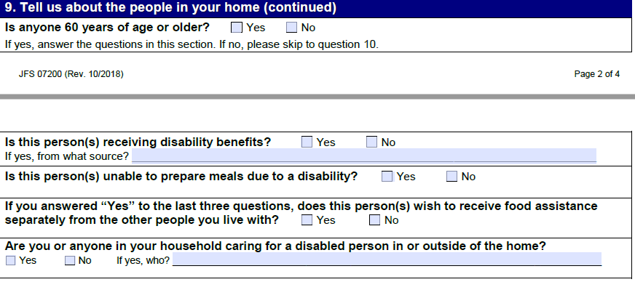
If the client is a single individual on the case, they answer these questions for themselves only. If they list others on their case, they answer these questions for anyone listed. If something I check as “Yes”, there will most likely be a request for backup documentation.
Part 10: Tell us about your finances
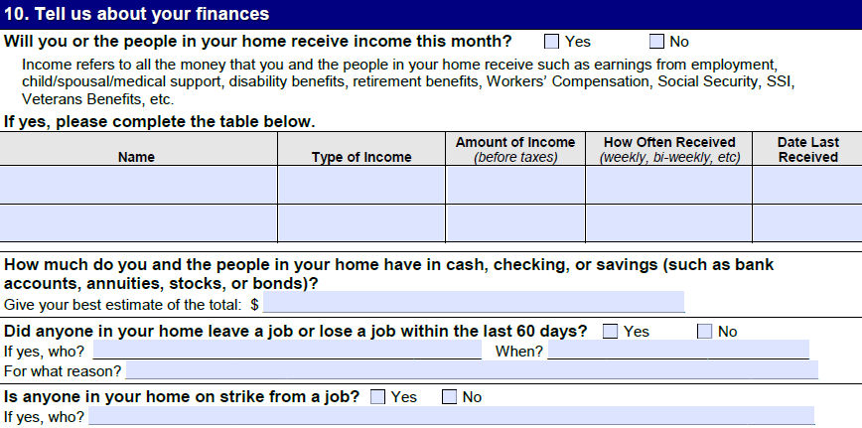
If the participant or listed case members have had any verifiable income in the last 30 days, they will need to provide the information here. They will also need to provide backup documentation (copies of paychecks, paystubs.) If they were hired at a job in the last 30 days, but have not been paid, they will need to get a signed letter from the employer (on letter head) stating: employee name, hire date, wage, number of hours worked on average per week, and pay schedule (weekly, bi weekly, monthly, etc.).
If they DO NOT HAVE ANY INCOME, they will need to complete the Zero Income Declaration form and it will be submitted with their application.
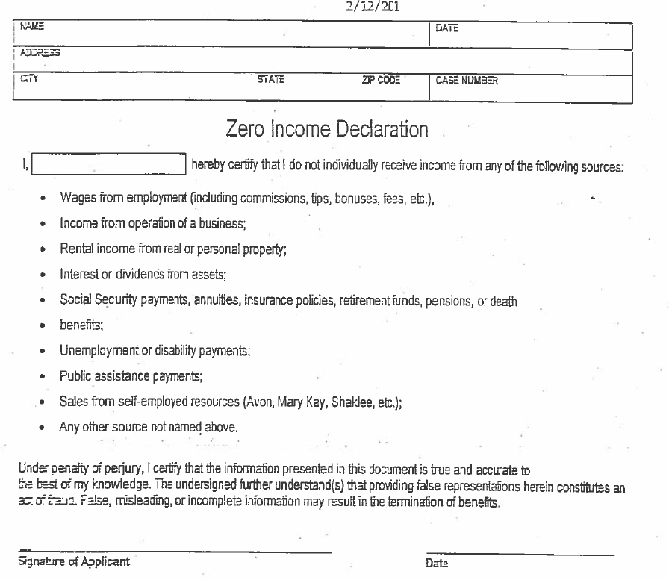

Part 11: Tell us about your expenses
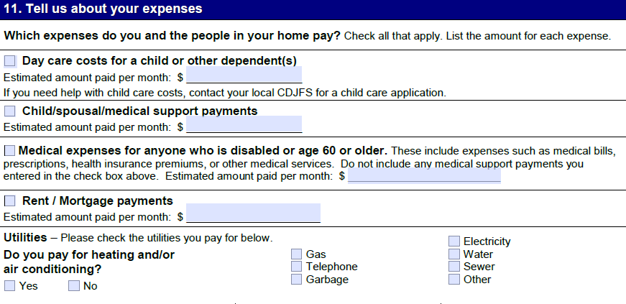
Again, this is only for the individual (s) listed on the case and anything that is marked as an expense will need backup documentation. If there are no expenses, fill each blank $ space with a zero, so the reviewer knows the section was not skipped. Here are some back up documentation examples:
- Day Care
  - Documentation from day care provider of amount paid in the last 30 days
- Child/Spousal/Medical Support
  - Documentation from the county to which support is paid (ex. Franklin County child Support)
- Medical Expenses
  - Documentation of anything lists as an example
- Rent/Mortgage payments
  - Lease or mortgage note with the participants name on it and the dollar amount owed monthly.
- Utilities
  - Utility bill with the participant’s name on it and the amount paid in the last 30 days.
  - If they pay money toward a bill, they MUST have an address verification for the address the utility is located at and a letter from whoever’s name is on the utility bill explaining that the person lives there and pays “$$” per month toward the bill.

Part 12: Signature of Person who completed this application
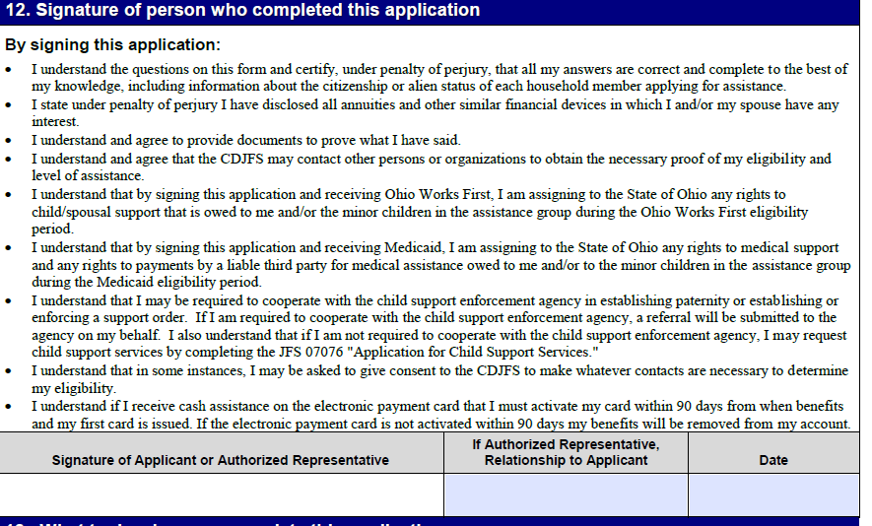

Sign and date

Part 13: What to do when you complete this application

Pathways has a relationship with the JFS Outreach team, who is supervised by Johnna Sawyers. Instead of turning applications in online or in person, our team sends them to Tamekia Moon via email wtgm25@fcdjfs.franklincountyohio.gov and copy Johnna Sawyers jsawyers@fcdjfs.franklincountyohio.gov as well as Pathways case managers

Please follow the following format
When submitting an application by email to the outreach unit please use the format below as this will enable streamlined processing of the application:

Subject line: Your agency name, Customer Last Name ( ex; Alvis , Smith)

Body of email: Please include all of the following information:
- Customers full name( first and last name),
- Type of engagement (Initial application, Re-application, Household Changes, or Benefit Inquiry)
- Any additional information that you feel will be pertinent to us processing the application.

Attachments: the following must be sent with each application (as applicable):
- Completed application,
- SNAP Release Form (if you are requesting case information to be shared with you)
- Medicaid Release Form (if you are requesting case information to be shared with you)
- Any supporting verification the customer has provided (ex: Identification, residency statement, income verification etc.)

NOTE: Do not include the customer’s social security number in the subject line or body of the email.
Please allow 24 hours for the completion of the request.

Consent and Release forms
CONSENT and RELEASE FORM REQUIREMENT: From this date forward, we will require consent and release forms with any application for which you, as the referring partner, will need benefit information provided back to you. This step ensures we are all in compliance when sharing customer information. If you are only submitting the application on behalf of the customer and do not require any benefit information back, you do not need to submit any additional forms. However, be aware that if we do not have a consent and release form on file or you are not assigned as the authorized representative on the case we will not be able to share ANY information related to the customer or their application status.
Common Phone Numbers

Reporting changes in phone numbers, addresses, etc.: 1-844-640-6446
EBT hotline to order replacement card or check balance: 1-866-386-3071
Medicaid Hotline to check on status of enrollment or choose a managed care plan: 800-324-8680

